**Azure Queue Storage**

1. Azure Queue storage helps to handle large volume of message in Queue .
2. It allow async communication between different applications.
3. Each message size max is 64Kb
4. Queue can be processed using Http/https.
5. Storage Queue is part of Storage account .
6. We can access Queue using Storage account Connection string and Queue name
7. Or we can access using Queue Url and Azure credential

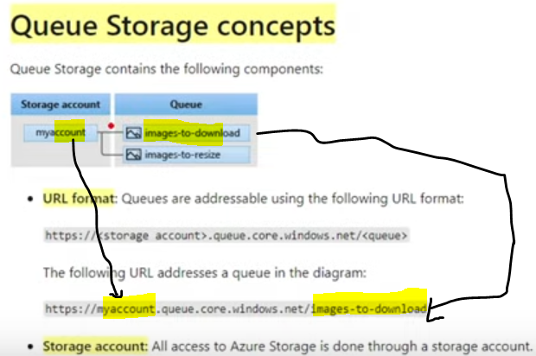

1. Create c# Web api
2. Add

Azure.Storage.Queues by Nuget Package manager

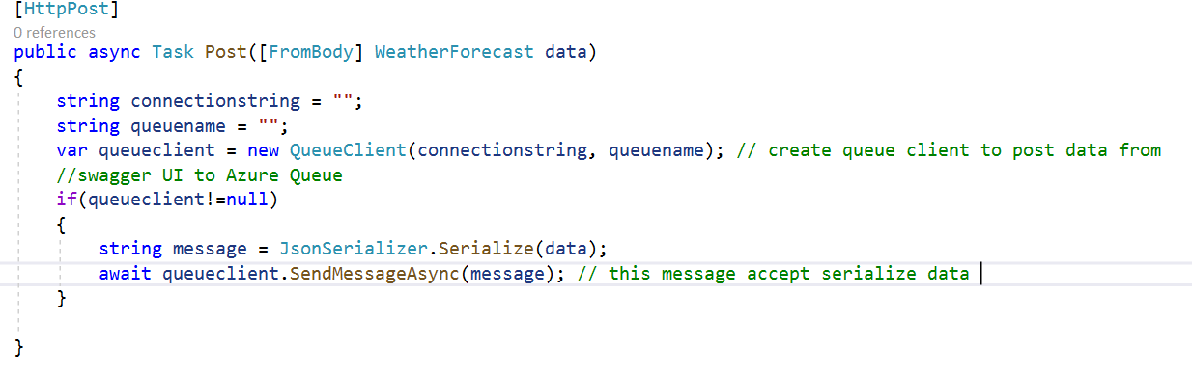

Then Create Storage Account

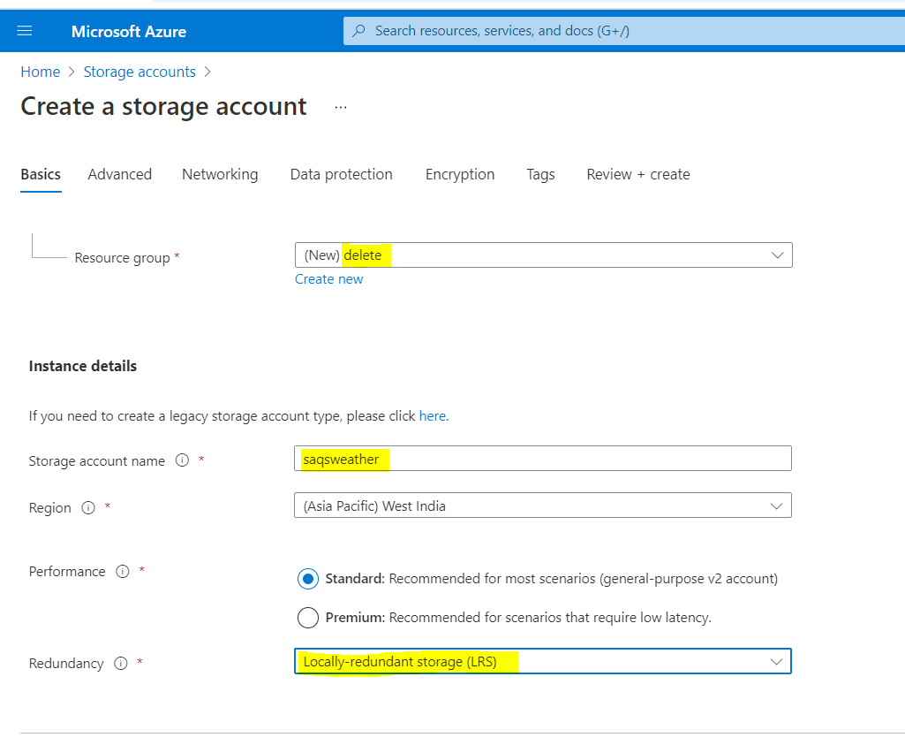

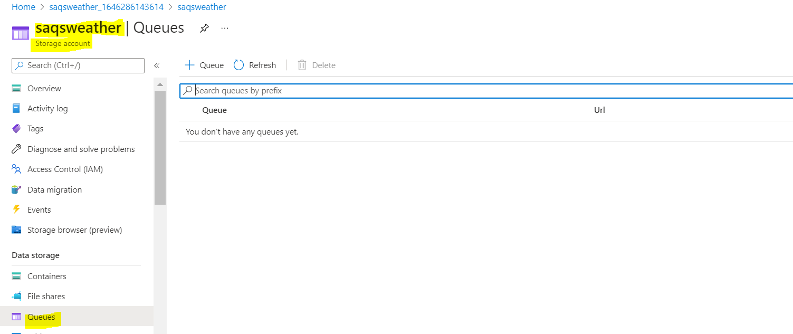

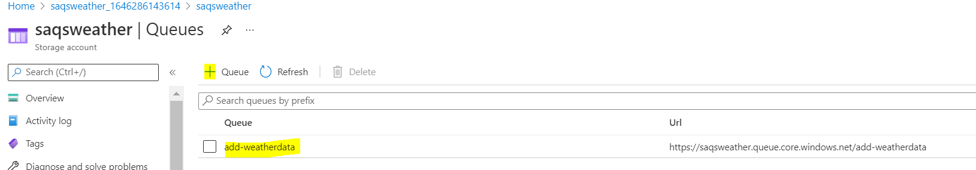

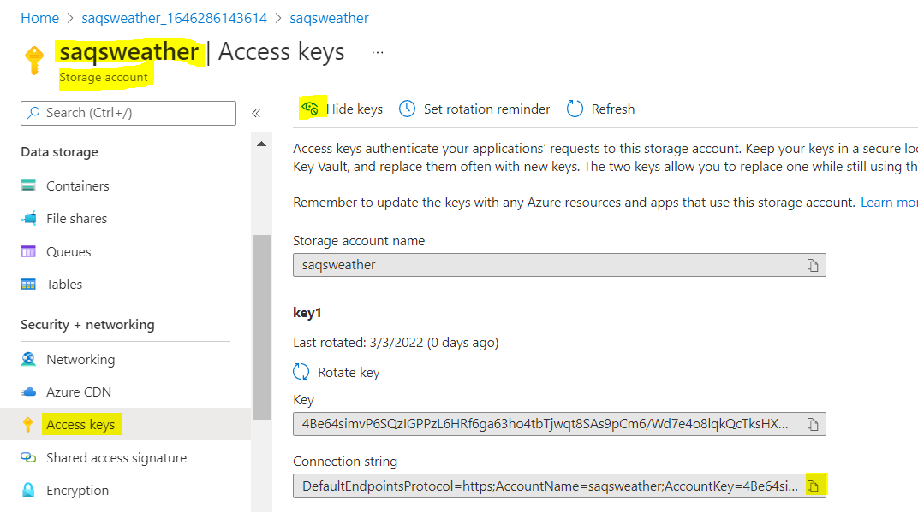

Then we run program and post data using swagger UI

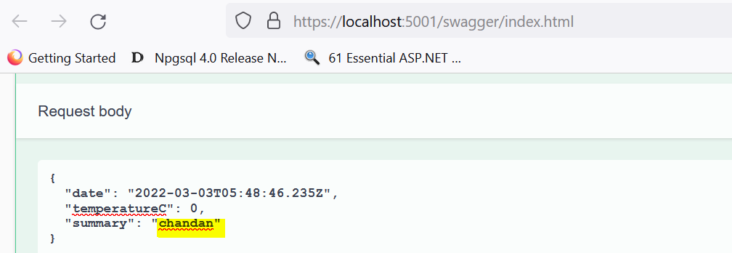

Now we can see data in Queue , by default Time duration of Message in queue is 7 days.

1. await queueclient.SendMessageAsync(message);

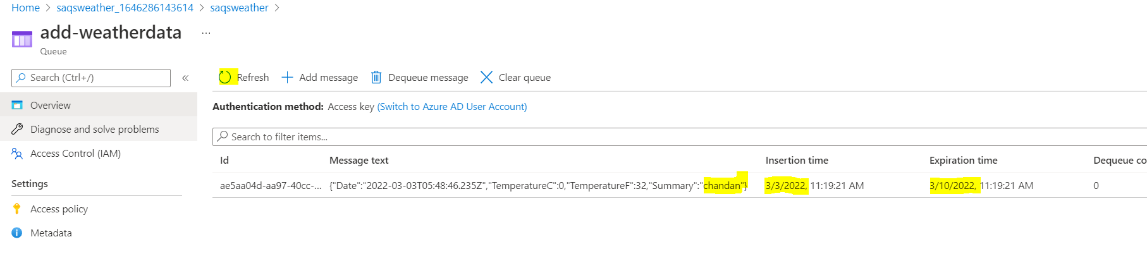

1. await queueclient.SendMessageAsync(message,null,TimeSpan.FromSeconds(10));, **after 10 seconds this message is removed**
2. Suppose we want to message comes after some interval in queue

Suppose I order someitem , I want to visible in Shipping queue , wait for 1 hr , so that shipping dept can process

await queueclient.SendMessageAsync(message,TimeSpan.FromSeconds(10),TimeSpan.FromSeconds(20)); here message will appear in 10 seconds

and expire in 20 seconds.



1. Suppose I don’t want to expire message from queue

await queueclient.SendMessageAsync(message,null,TimeSpan.FromSeconds**(-1**));

Now lets create Background service class which will consumer for Weather Queue

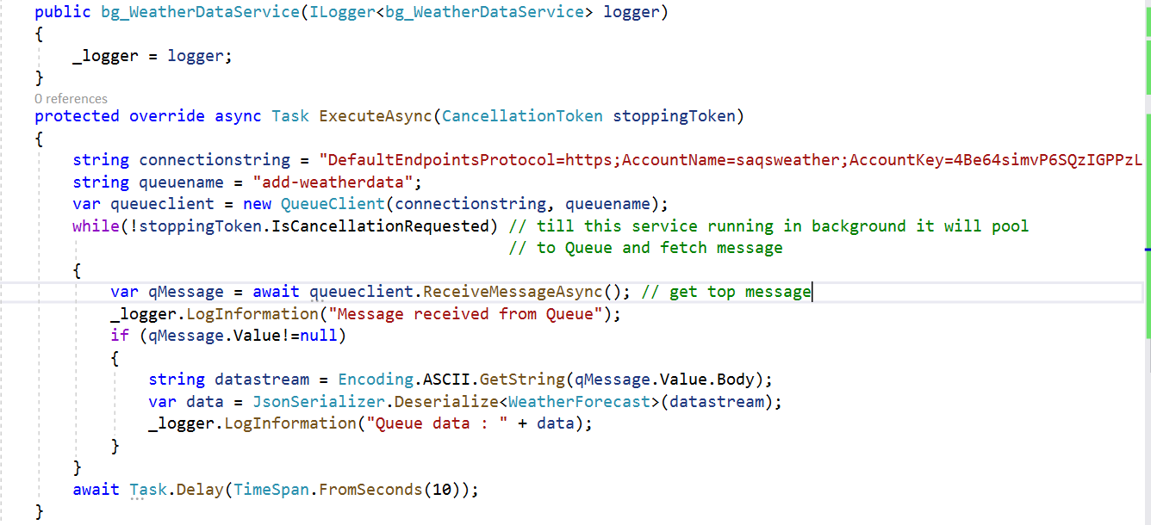

But this will not delete message from queue , message will reappear in queue after some time with message Dequeue count reach to 5

So if we want to delete message from queue after processing/read from queue

// this will delete message once read

await queueclient.DeleteMessageAsync(qMessage.Value.MessageId, qMessage.Value.PopReceipt);

Suppose we want to only read message in queue then instead of read will use peek message.

Now lets use Dependency Injection for Queue Client

1. Add Microsoft.Extensions.Azure
2. 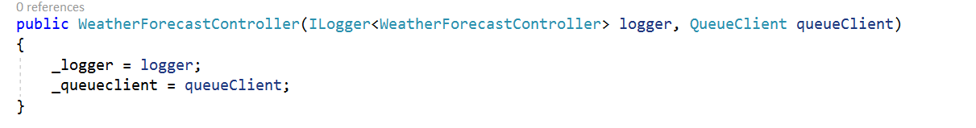
3. 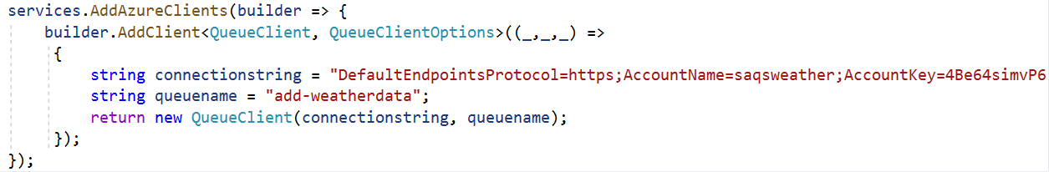

Now instead of using connection string we an use “Manage Identity “ for the user who is using the resource

a.

